School BUS App

Driver App

Parents App

Arun- can look at this app…for comparison….

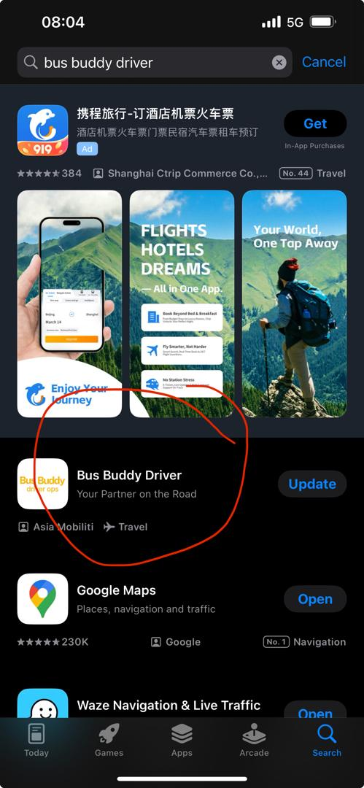

Comments on our App

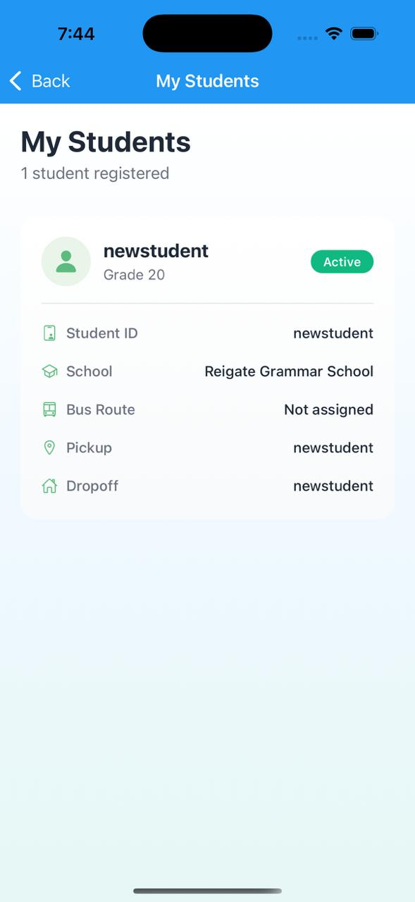

On this page- suggested to capture- Parent Contact, Grade, Level, DOB, Age- sample below

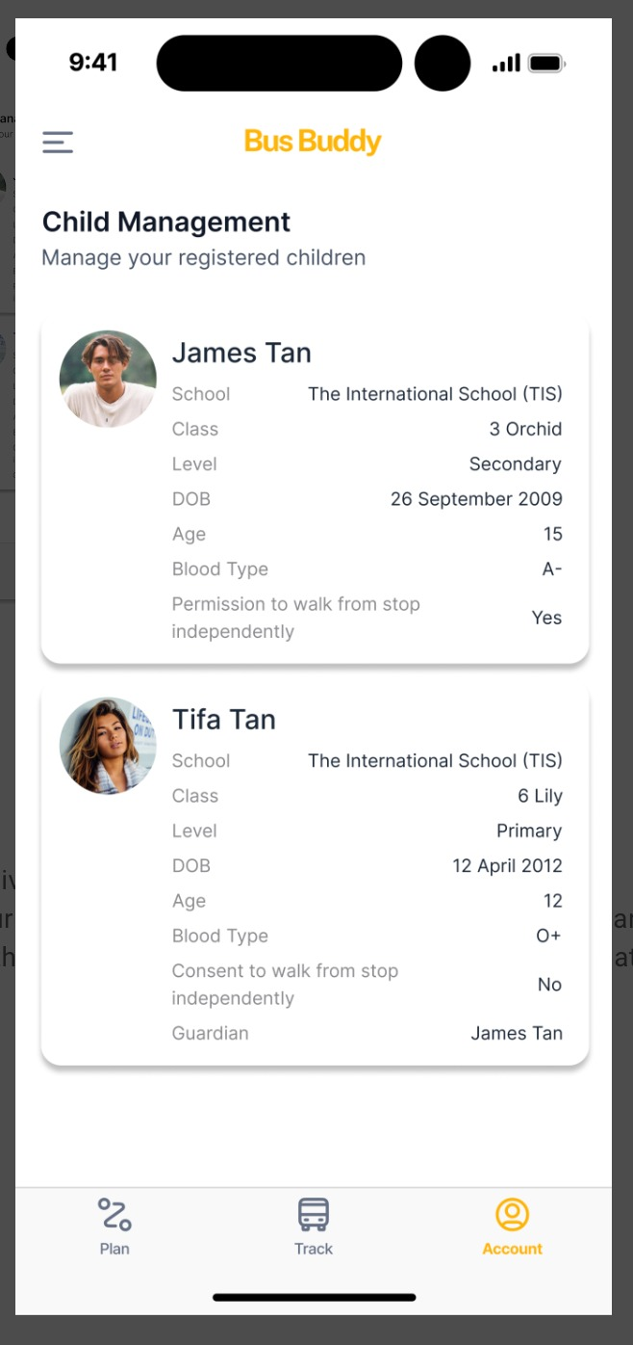
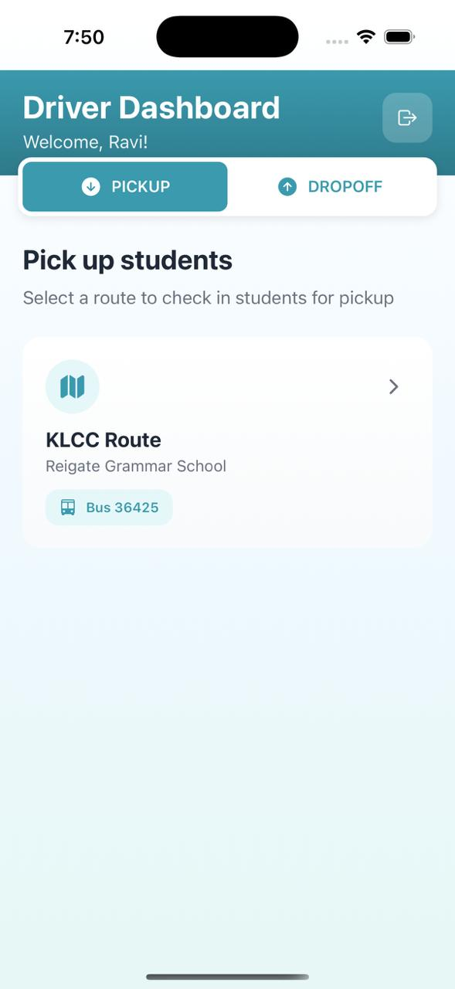

Suppose to have search function here right?

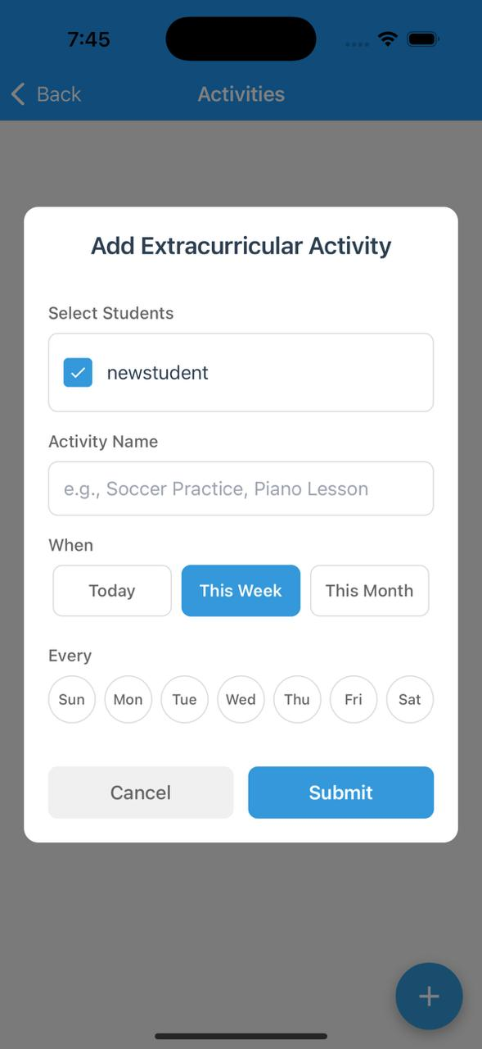

This one – can it be any way that from the backend we can control the time that they can choose. Fixed time of 3:00 and 4:00, etc?

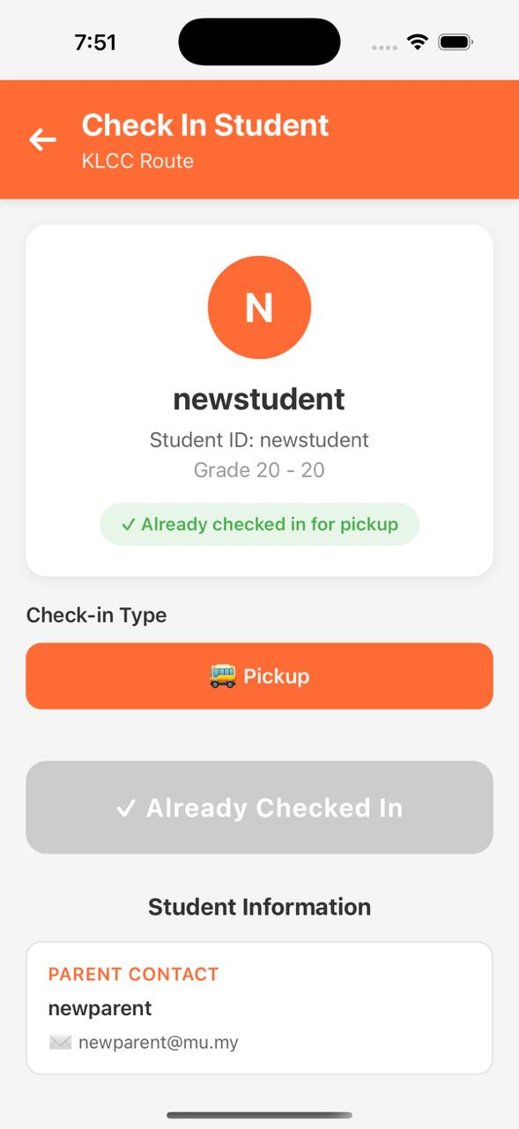

Parent contact number – if can column for two numbers
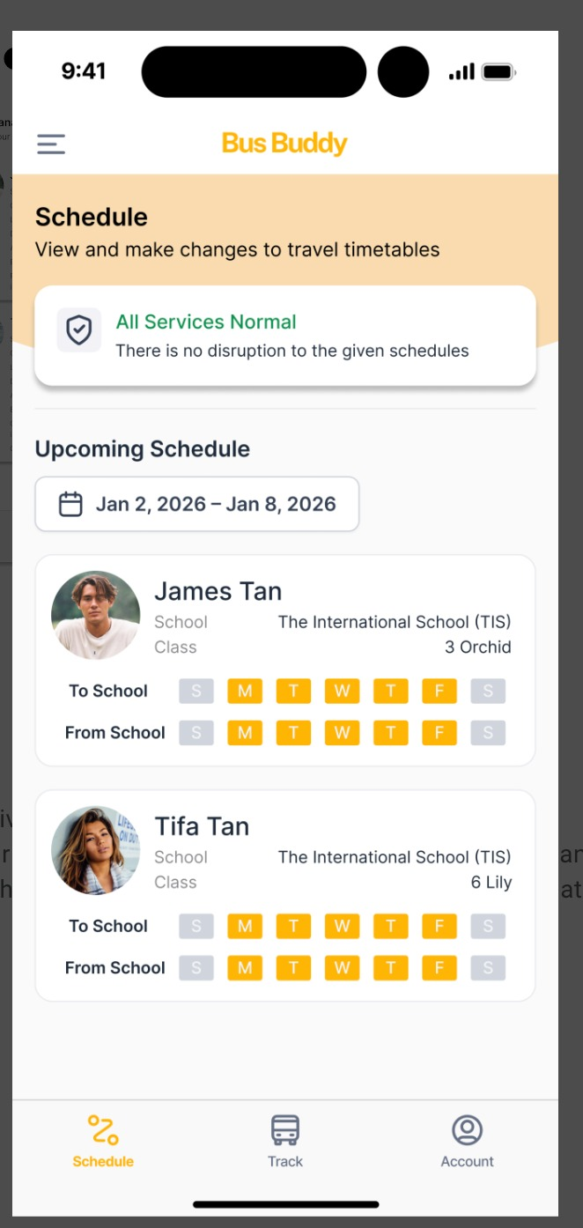
This looks nicer then what we have. We should have to upload photo but not compulsory for now.

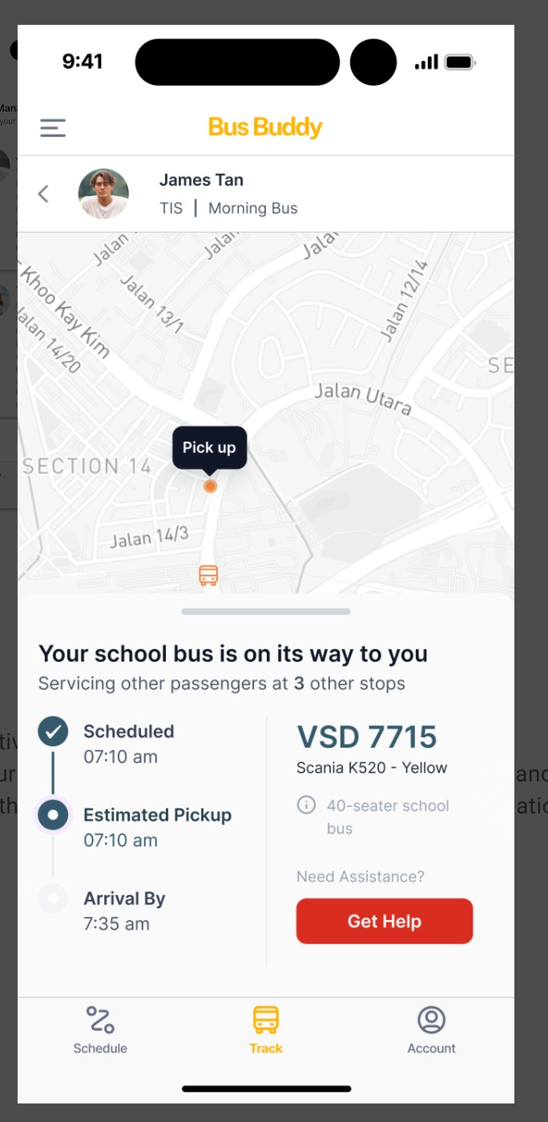

This one- driver have to checkout to populate-ok

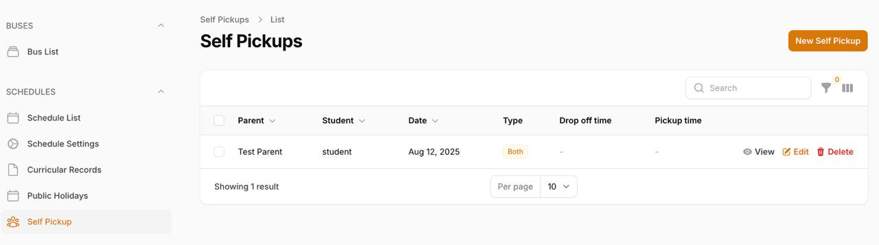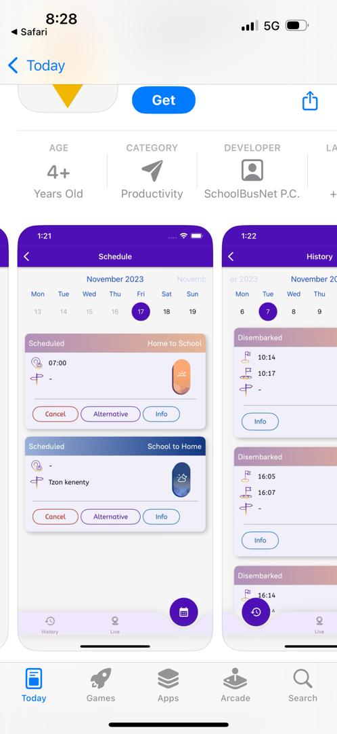

This same like as our self-pickup but it appears as alternative in the list so driver knows parent is self picking up?

